Git assignment

Section 1

Q1

$ mkdir project_dir

$ cd project_dir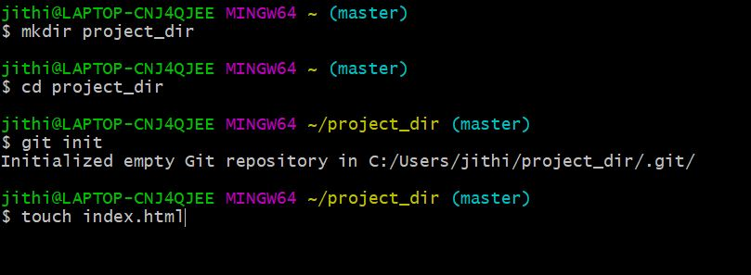

Q2

$ git init

Initialized empty Git repository in C:/Users/jithi/project_dir/.git/

Q3

$ touch index.html

Q4

$ git status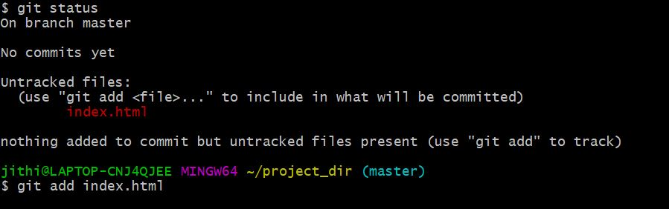

Q5

$ git add index.html

Q6

$ git commit -m"First commit for index.html"

[master (root-commit) bf39aeb] First commit for index.html

1 file changed, 0 insertions(+), 0 deletions(-)

create mode 100644 index.html

Q7

touch info.txt

Q8

$ git status

On branch master

Changes not staged for commit:

(use "git add <file>..." to update what will be committed)

(use "git restore <file>..." to discard changes in working directory)

modified: index.html

Untracked files:

(use "git add <file>..." to include in what will be committed)

info.txt

Q9

touch .gitignore

.*txt inside .gitignore

Q10

git status

Q11

$ git add index.html

$git commit -m"Second commit"

Q12

$ git log

Q13

Q14

$ git checkout --index.html

Q15

Q16

$ git add index.html

Q17

$ git restore --staged index.html

Q18

$ git config --global alias.my-add add

Q19

$ git my-add index.html

$ git commit -m" Commiting again_second"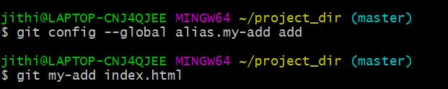

Q20

$ git revert becce52a8d8a4ab318cd15fa50605480d40158ed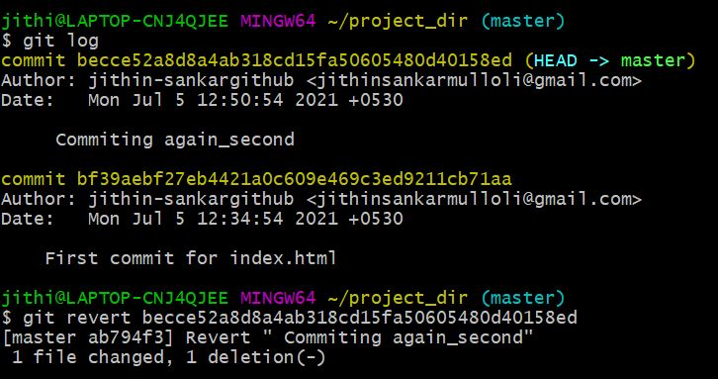

**Section 2 --Html branching assignment**

Q21

Q22

$ mkdir Assignments

$ cd Assignments

$ git init

Initialized empty Git repository in C:/Users/jithi/Assignments/.git/

Q23

$git touch README.txt

Q24

$ git add README.txt

$ git commit -m"First commit for readme.txt"

Q25

$ git branch html_assignments

Q26

$git checkout html_assignments

Q28

$ git add firstassignment.html

$ git commit -m"First commit"

Q29

$ git add .

Q30

$ git commit -m"Third commit on readme"

[master 9775f84] Third commit on readme

1 file changed, 2 insertions(+), 1 deletion(-)

Q31

$ git checkout master

Q33

git checkout html_assignments

Q34,Q35,Q36

$ git add .

$ git commit -m"fourth commit on brach html"

[html_assignments e2bb336] fourth commit on brach html

2 files changed, 3 insertions(+), 2 deletions(-)

$ git checkout master

Switched to branch 'master'

Q37

$ git merge html_assignments

$ cat README.txt

$ vi README.txt

Q38

$ git branch -d html_assignments

Deleted branch html_assignments (was e2bb336). Html branching assignment

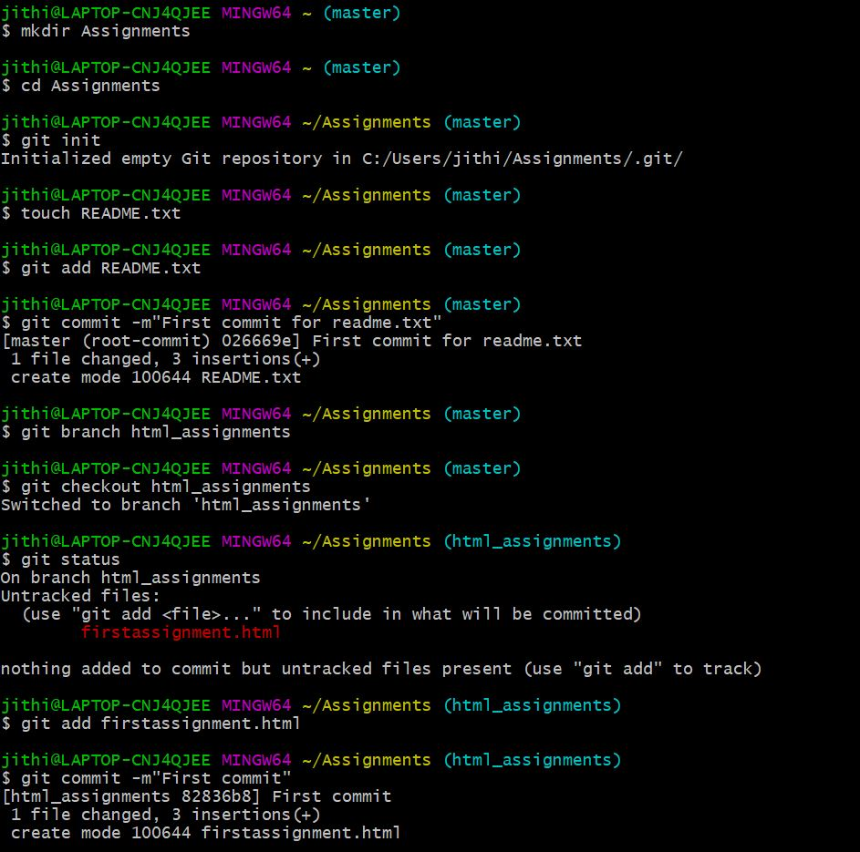

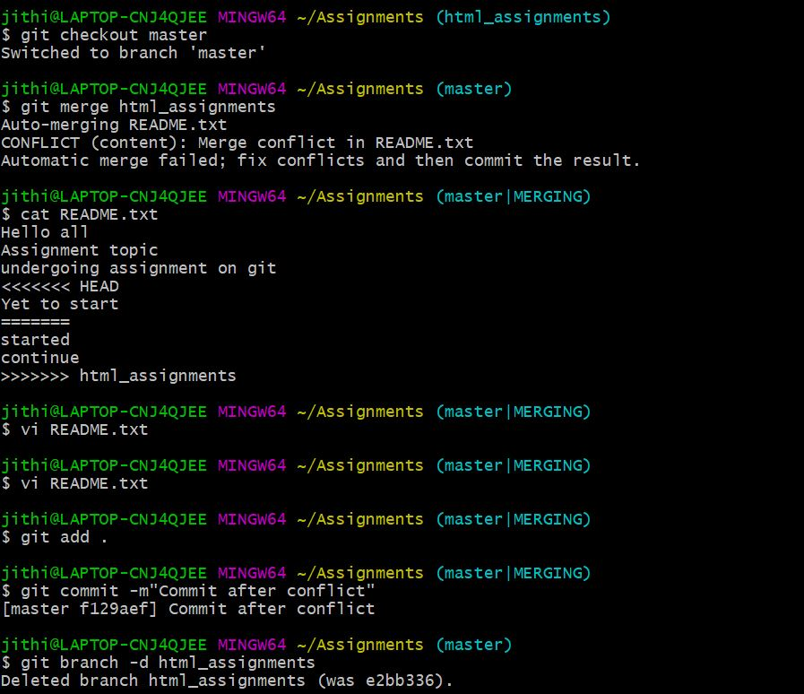

**Section 3 CSS Assignment**

Q1

$ git branch css_assignments

Q2

$ git checkout css_assignments

Q3

$ git add .

Q4

$ git commit -m "First commit on css"

Q5

$ touch READMe.txt

Q6

$ git add .

$ git commit -m"Commit after edit in readme"

[css_assignments df42d9f] Commit after edit in readme

1 file changed, 1 insertion(+), 2 deletions(-)

Q7

$ git checkout master

Q8

$ git add .

$ git commit -m"Commit after change in master"

Q9

$ git checkout css_assignments

Q10

$ git add .

Q11

$ git commit -m"commit after change in docs in css branch"

Q12

$ git checkout master

Q13

$ git merge css_assignments

$ cat README.txt

$ vi README.txt

Q14

$ git branch -d css_assignments

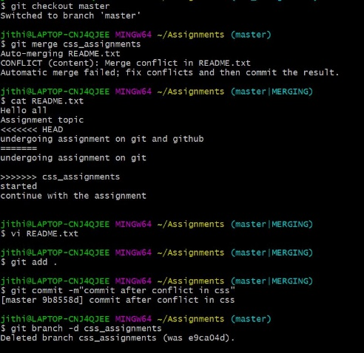

**Section 5 Js assignment**

Q1

$ git branch js_assignments

Q2

$ git checkout js_assignments

Q3

$ git add .

Q4

$ git commit -m "First commit in js branch"

Q5

$ touch README.txt

Q6

$ git add .

$ git commit -m"commiting changes after edit in readme"

[js_assignments fae9097] commiting changes after edit in readme

1 file changed, 1 insertion(+), 1 deletion(-)

Q7

$ git checkout master

Q8

$ git add .

$ git commit -m"commit after change on readme file on master"

[master 65e300b] commit after change on readme file on master

1 file changed, 1 insertion(+), 1 deletion(-)

Q9

$ git checkout js_assignments

Q10

$ git add .

Q11

$ git commit -m "commiting last changes"

[js_assignments dbb5564] commiting last changes

1 file changed, 1 insertion(+), 1 deletion(-)

Q12

$ git checkout master

Q13

$ git merge js_assignments

Auto-merging README.txt

CONFLICT (content): Merge conflict in README.txt

Automatic merge failed; fix conflicts and then commit the result.

$ cat README.txt

Q14

$ git branch -d js_assignments

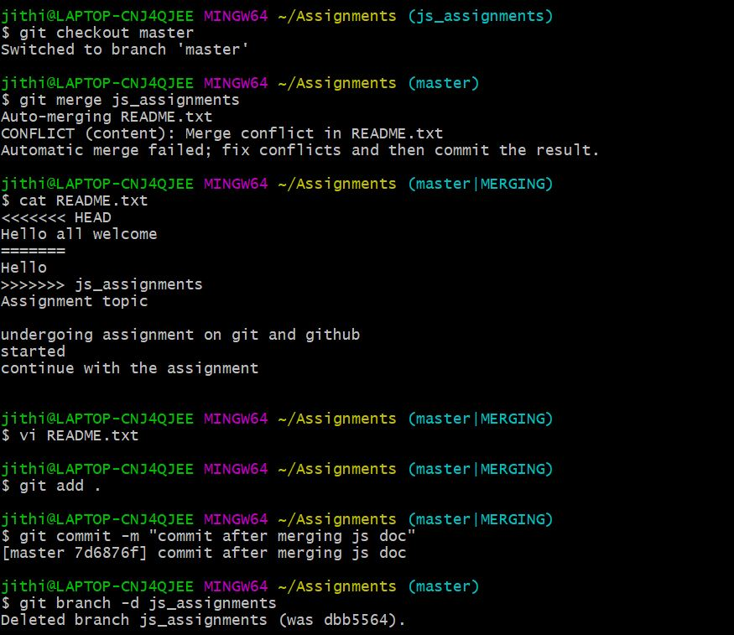

**Git Remoting**

**Section 3 and 4**

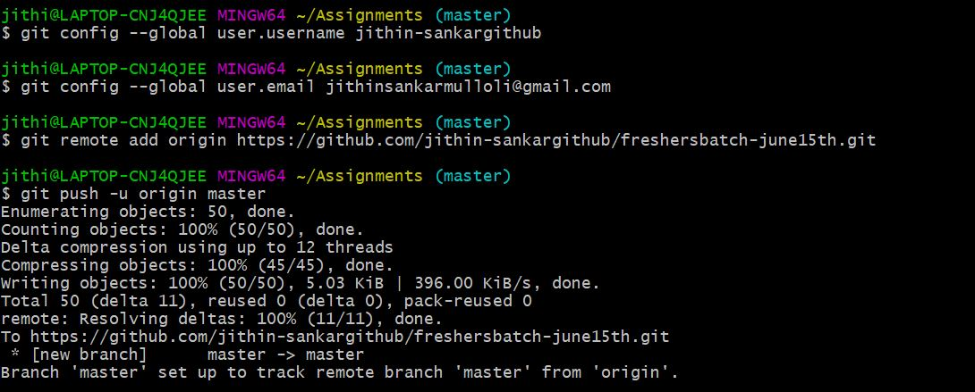

**Github Repo**

